**Working From Home Explained by Employee Reviews**

**Boe Fellowship Report**

**Amanda Aird**

**September 17, 2021**

**Background**

Working from home is not a new concept, but, as the Covid-19 pandemic began, many workers were forced to move from their typical office to a home office setting. Many workers today have all the tools they need to do their job from home, especially in the technology industry. Employees can use their computer to get their projects done and video conferencing in place of in-person meetings. This paper uses reviews from employees in the technology industry to see what employees have to say about working from home. With the growing popularity of employee review sites, employees can talk about what they think about their job. Employees can also review many aspects of their company and position, and they can list the pros and cons of their job. This paper will look at when employees talk about remote work as pros or as cons to find reason employees have to classify remote work as “good” or “bad”.

**Related Literature**

*Employee Reviews*

Online employee reviews help provide insights to what employees’ think about their current and former companies. Employees can leave reviews on websites such as Glassdoor.com and give feedback with pros, cons, overall ratings, and much more. The validity of overall ratings on Glassdoor.com is supported through moderate correlation with Federal Employee Viewpoint Surveys (Landers, Brusso, and Auer, 2019). This opens up numerous research opportunities, including using reviews to analyze turnover and firm performance.

Online employee reviews provide the opportunity to research employee satisfaction from a text mining approach. Job satisfaction factors can be identified from online reviews through a Latent Dirichlet Allocation (Jung and Suh, 2019).

Online employee reviews also have an impact on how job-seekers view companies. Companies with higher levels of contradicting reviews led to job-seekers avoiding applications with those specific companies (Könsgen, Schaarschmidt, Ivens, and Munzel, 2018).

Glassdoor.com reviews have also been used to evaluate interpersonal and intrapersonal cultural heterogeneity of firms (Corritore, Goldberg, and Srivastava, 2020). Corritore et al found that interpersonal heterogeneity has negative implications for organizations while intrapersonal heterogeneity has positive implications for organizations.

Using Glassdoor.com reviews to measure specific metrics of employee satisfaction has further confirmed higher general employee satisfaction improves company performance (Ning, Zhou, and Shon, 2016). Ning et al used text analytics to measure employee satisfaction over nine dimensions: Integrity, Teamwork, Innovation, Respect, Quality, Safety, Community, Communication, and Reward. In the technology industry, employees are most commonly adding comments on Innovation to their reviews (Ning, Zhou, and Shon, 2016). Technology employees have also been shown to put more importance towards work-life balance (Sainju, Hartwell, and Edwards, 2021).

*Remote Work*

Remote work can also have a major impact on employee satisfaction and productivity at work. They type of job an employee has is important in considering if working from home is a good idea for an employee (Belanger 1999). The training, or lack thereof, that and employee receives is also likely to have an influence on the specific outcomes of an employee working remotely (Baker 2007).

**Data Collection**

*Scraping Glassdoor Data*

The review data was collected from the website *Glassdoor.com.* This website gives employees the ability to rank different aspects of the companies they work for and previous companies they were employed by. The reviews consist of 1-5 star rankings on different aspects of the company, an overall 1-5 star rating, a main comment, a pros section, and a cons section. These reviews also provide basic demographic information on the reviewer. This includes if they are a former or current employee, the length of their tenure with the company, their location, their position, and the number of people that found their review helpful.

The data used for this analysis looked at 209 different companies from the Information Technology and Communication services sectors in the Russell 1000 index. Companies in the Communication Services industry include companies such as Google, AT&T, and The New York Times. Companies in the Infromation Technology sector include companies such as Adobe, Apple, and Microsoft. Out of the 230 companies from these sectors, 21 companies either had less than 10 reviews on their Glassdoor profile or did not have a profile for employee reviews. The remaining 209 companies were all used in this analysis.

*Demographics of Reviewers*

After collecting the data, we looked at what type of employees were leaving reviews, when they were leaving reviews, and the number of reviews each company had. Below is a list of basic demographic information on the employees that posted the reviews used in our dataset.

Employee Status:

Number of companies: 209

Count total reviews: 649,363

Current vs Former:

Current Employee 411602

Current Intern 2

Former Employee 237757

Former Intern 2

Employee Experience with Company:

Less than 1 year 59759

More than 1 year 111574

More than 3 years 91315

More than 5 years 60227

More than 8 years 30507

More than 10 years 46598

N/A 249383

From the 209 companies, there was a total of almost 650,000 reviews. A strong majority of those reviews came from current employees, while only 4 of the reviews came from interns. Just under half of the employees did not leave information on how long they had been working with the company, but the most common length of tenure with the company was just over 1 year. And the majority of those who left information on how long they had been with the company had been there for less than 5 years.

Figure 1 gives the distribution over time for when the reviews in our dataset were posted. The reviews in the dataset range from being posted in 2008 all the way up to 2021. This data was collected in June of 2021, so all reviews are from that month or earlier.

Date Distribution of Reviews:

Figure1:

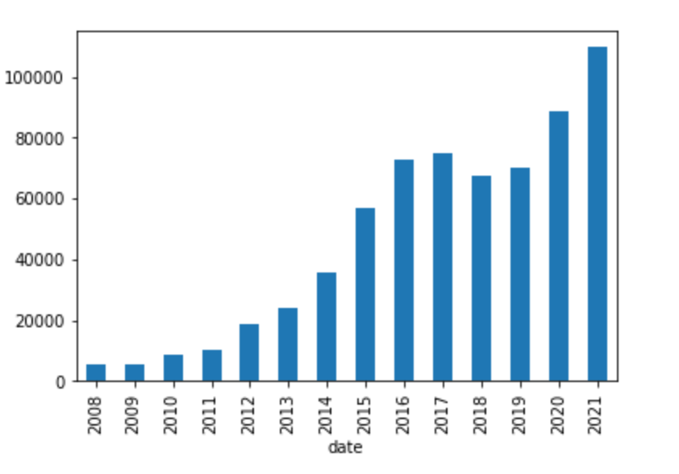

Figure 1 also shows the surge in employee reviews over the past recent years, especially in 2021. We can see that Glassdoor has become more and more popular since it was first used for reviews, with a small dip in 2018. But in 2021, with only half of the year over, the reviews had already surpassed the total number of reviews from 2020

Figures 2 and 3 show the distribution for the number of reviews each company had. On average, companies had around 1000 reviews, but this ranged from just under 20 reviews all the way up to almost 60,000 reviews for one company.

Number of Reviews Distribution:

Figure 2: Figure 3:

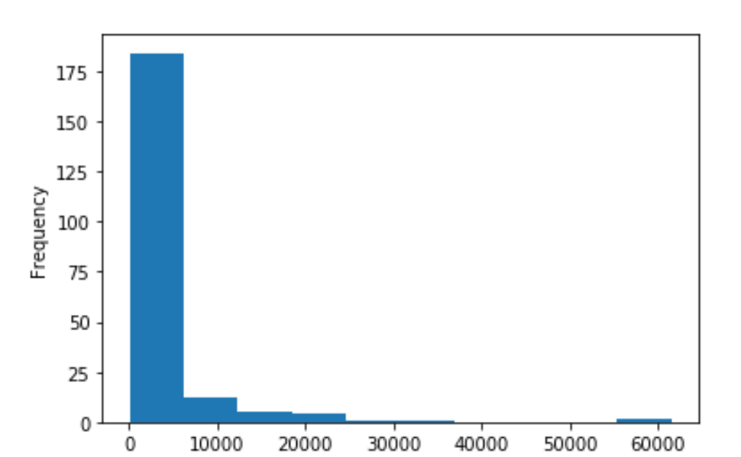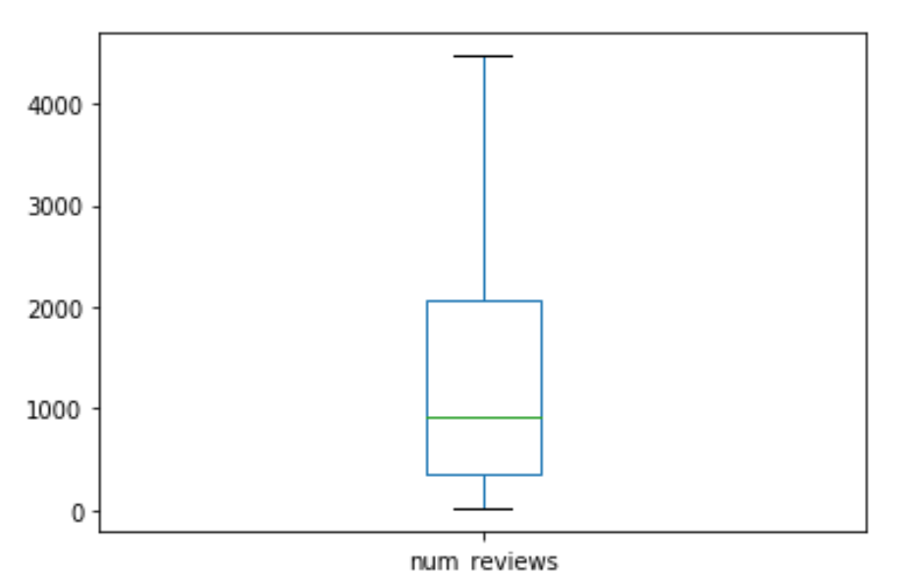

**Model**

*Discussions of Working from Homes*

To begin our analysis, a sub-dataset was created for reviews that included mention of working from home in their pros or cons section. Any reviews that mention “WFH”, “Work From Home”, “Remote”, or “Working From Home” were included in this group. Table 1 shows the amount of reviews that mention WFH in either the pros or cons and separates them based on if they were posted before March 2020 (precovid) or after March 2020 (postcovid). Next to the WFH pros and cons reviews is the proportion of them out of the precovid or postcovid reviews. Surprisingly, WFH was mentioned less in postcovid reviews than it was in precovid reviews.

Table 1:

|  | **Precovid** | **Postcovid** |
| --- | --- | --- |
| **Total Reviews** | 70058 | 134269 |
| **WFH Pros** | 1592 (.0227) | 2237 (.017) |
| **WFH Cons** | 730 (.010) | 982 (.007) |

Next, word clouds were created for the pros and cons of reviews. The first two word clouds shown were created looking at all of the reviews. The last two word clouds show the reviews where WFH was mentioned in the pros and mentioned in the cons respectively. We can see that when WFH is talked about in the pros or cons, these reviews are typically much different from the typical review. When looking at all reviews, resources, team, and excellent were some of the most mentioned words in the pros. But in the cons, people were often talking about the organization, crunch time, and a challenging environment. However, when it came to reviews that mention WFH, we see different common words show up for both the pros and cons.

All Reviews:

Pros: Cons:

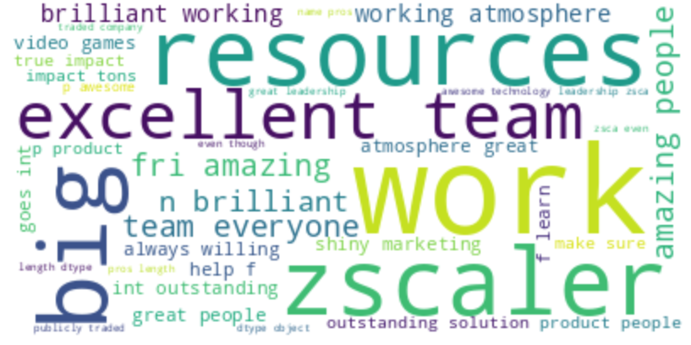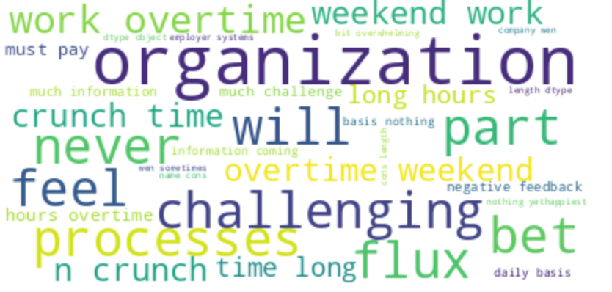

Work From Home Reviews:

Pros: Cons:

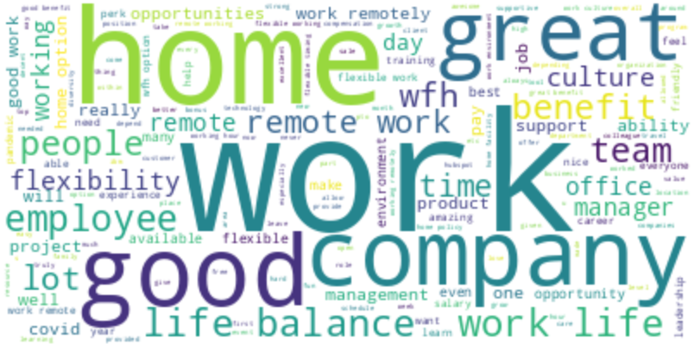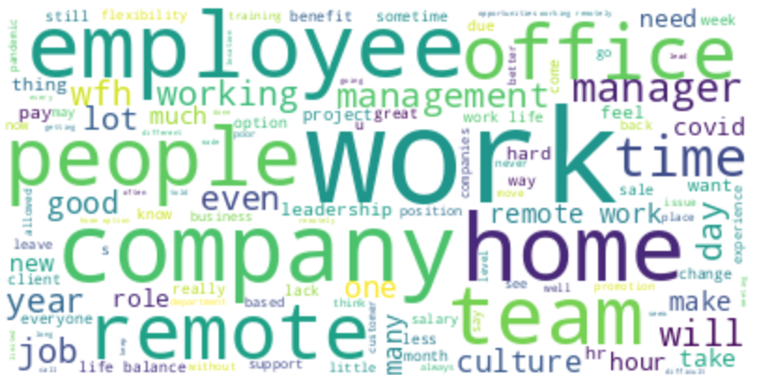

*LDA Modeling*

Next, Latent Dirichlet Allocation (LDA) models were created to use topic modelling on our reviews. We used four separated corpuses to get four different LDA models for comparison. The first set of LDA models uses all of the reviews in the dataset, while the second set of LDA models uses only the reviews where WFH was mentioned in the pros or in the cons. The first two models use the same data set, while the last two models use separate sets of reviews. Reviews are only in the WFH pros model if WFH was mentioned in the pros. And, reviews are only in the WFH cons model if WFH was mentioned in the cons. As shown earlier, WFH was mentioned more than twice as much in pros than it was in cons, so there were about double the reviews used for the the WFH pros model than the WFH cons model.

Stopwords were removed from each corpus using the nlkt stopwords package, and stopwords were extended to include “work” in all reviews and “work from home”, “WFH”, and “remote” in the WFH related reviews. A dictionary was then created using the nltk package. The models were build with ten topics in each model to allow for easy comparison between each model. The results for these models are shown below.

*LDA Models of All Reviews*

Pros: Cons:

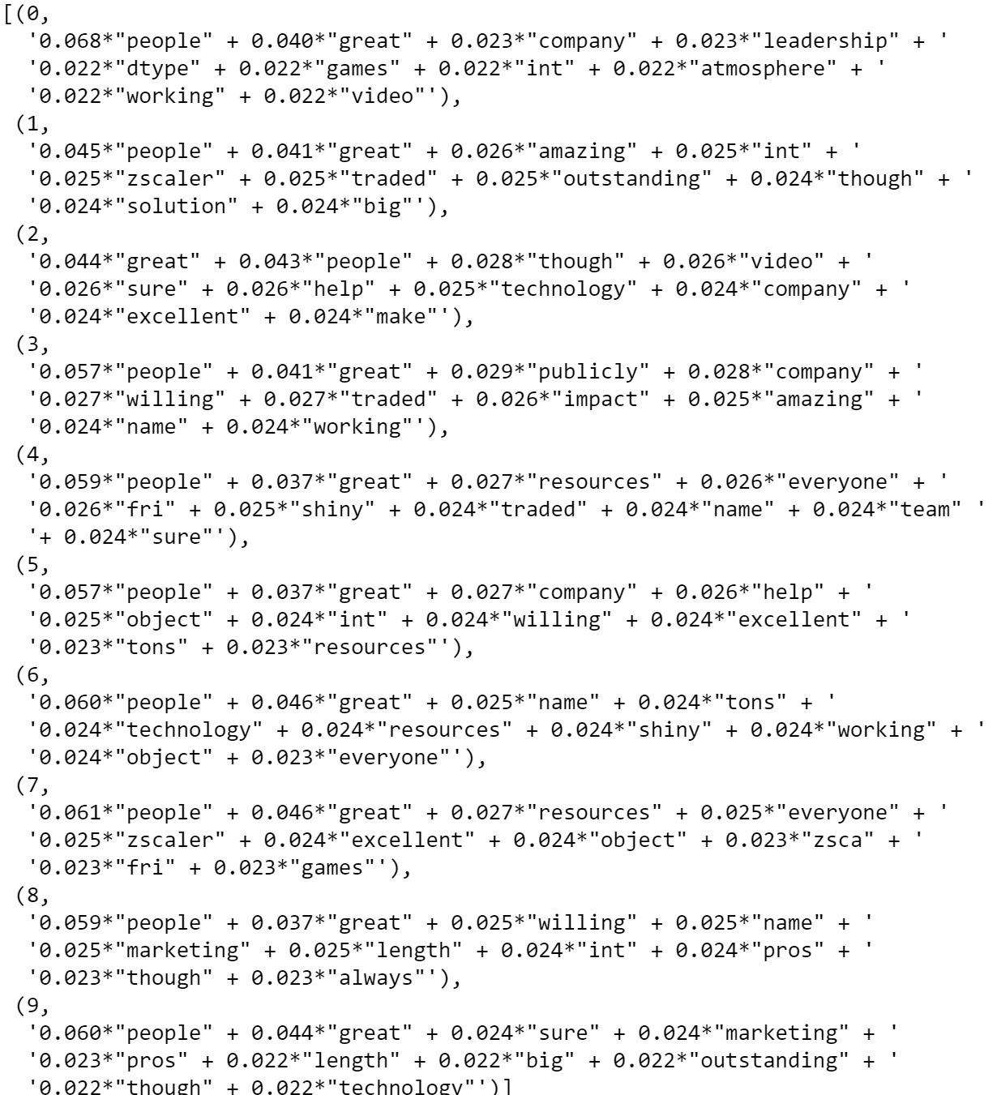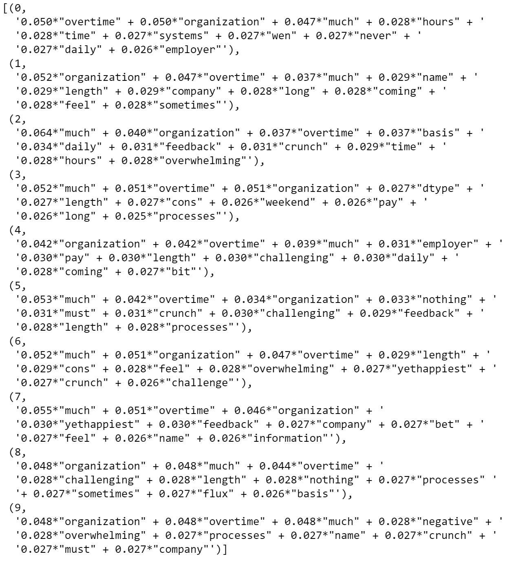

*LDA Models of Work From Home Reviews*

Pros: Cons:

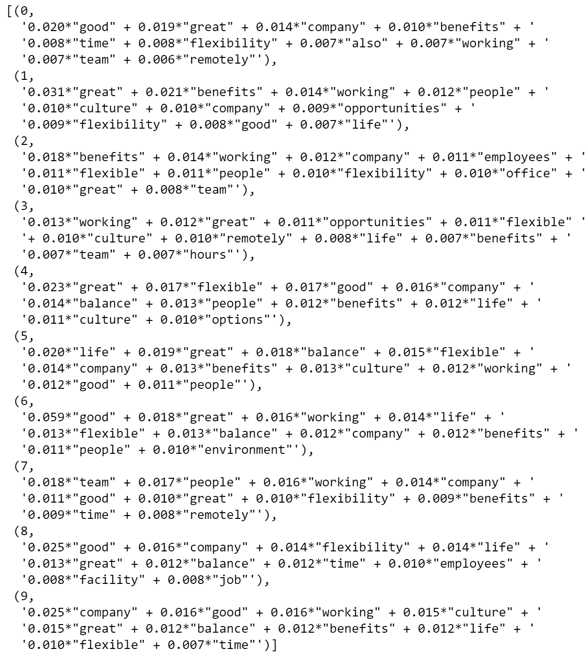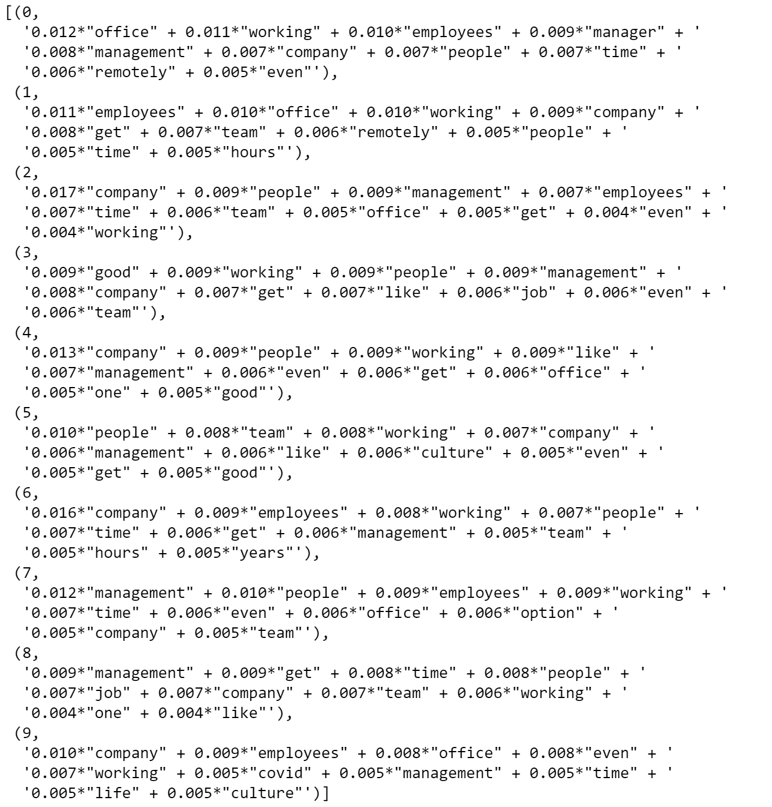

**Results**

By first looking at the LDA models that use all reviews, we can see that the topics are much different between the pros and the cons. This result was expected. Looking at the first topic of each model, we can see that employees talk about the people, leadership, and atmosphere in the pros, while the cons are focused on overtime, hours, and systems. Comparing each topic from the pros and cons, we can see this pattern continue. Almost all topics in the pros model include the word “people”, while almost all topics in the cons model involve the word “overtime”

The LDA models also show us that there are many differences between what employees are talking about when they mention WFH as a pro and when they mention it as a con. In the first topic of the WFH pros model there are words like benefits, time, and flexibility. In the WFH cons model the first topic includes words like employees, manager, and management. All of the topics in the WFH pros model include the either flexible or flexibility. And, almost all of the topics in the WFH cons model include the word management.

Further, there are differences between the two pros models and the two cons models. The topics do not appear to be the same between the pros when WFH is mentioned and the pros from all of the reviews. Similarly, they are not the same between the cons when WFH is mentioned and the cons from all of the reviews.

**Discussion**

The differences between the topics in all four of the LDA models show that there are different factors that influence job satisfaction negatively or positively. Further, it shows that these factors also differ when working from home is mentioned.

For the model of pros in all reviews, “people” was a word used for every topic. Topics revolving around the people you work with or around tend to be the most common topics that come up the most in the pros section of all the reviews looked at. For the model of cons in all reviews, overtime was a word in every topic. So, people are most often commenting on long hours and topics around the hours that they work as a con for their job and company. This makes sense, as working around good people can strongly improve an employees experience with a company. On the other hand, working long hours, and not having much time outside of work can lead to a very negative experience with the company.

When we looked at only the reviews that include working from home in their pros or cons, we saw different topics come up in the pros and cons. We saw in the pros for the WFH model that every topic include flexibility, and all topics for the cons WFH model include management. This shows topics we expect to see, as flexibility is a very common benefit mentioned for WFH. So, to see the topics from the WFH pros model revolving around flexibility, we can see that people who think of work from home as a pro see remote work as a flexible option. The interpretation for management being a common word among the WFH cons topics is not as immediate, but a few different interpretations can be made. Because WFH does not provide as much in person interaction with management, it could be more difficult for managers to communicate as effectively with their employees, making the management of working from home a con. Looking closer at what management systems look like for employees that work from home will be useful in determining why it is a common word in topics for WFH cons.

Because the pros and cons models have topics that revolve around different words, we can see that when people relate working from home to the satisfaction of their job, they are talking about different pros and cons than people who do not mention working from home. The comments employees have about working from home, whether in the pros or cons of their review, will likely revolve or be based on different topics than people who do not take working from home into consideration in their reviews.

**Directions for Future Research**

This paper exclusively looks at employee reviews for information technology and communication services companies. Expanding this research to also include companies in other sectors would be useful in further interpreting the topic models from the technology and communication industries, along with finding differences in work from home standards between industries.

Further, using data from LinkedIn to better understand the employees of companies would be useful in interpreting their employee reviews. For this project, data collection from LinkedIn was unsuccessful. However, LinkedIn profiles give insights into the employees of a company. This will allow us to have a much deeper understanding of the experience and demographics of the employees at each company. It will also show the movement of employees between companies. Seeing what companies employees to and from, will be helpful in understanding employee satisfaction and why they might view working from home as a pro or a con.

**References**

Baker, E., Avery, G. C. & Crawford, J. (2007). Satisfaction and Perceived Productivity when Professionals Work From Home, Research and Practice in Human Resource Management, 15(1), 37-62.

Belanger, F. (1999). Workers’ propensity to telecommute: An empirical study. Information and Management, 35(3), 139–53.

Corritore, Matthew, Goldberg, Amir, and Srivastava, Sameer B. "Duality in Diversity: How Intrapersonal and Interpersonal Cultural Heterogeneity Relate to Firm Performance." Administrative Science Quarterly 65, no. 2 (2020): 359-94.

Gardner, Timothy M, Wright, Patrick M, and Moynihan, Lisa M. "THE IMPACT OF MOTIVATION, EMPOWERMENT, AND SKILL-ENHANCING PRACTICES ON AGGREGATE VOLUNTARY TURNOVER: THE MEDIATING EFFECT OF COLLECTIVE AFFECTIVE COMMITMENT." Personnel Psychology 64, no. 2 (2011): 315-50.

Hancock, Julie I, Allen, David G, Bosco, Frank A, McDaniel, Karen R, and Pierce, Charles A. "Meta-Analytic Review of Employee Turnover as a Predictor of Firm Performance." Journal of Management 39, no. 3 (2013): 573-603.

Hom, Peter W, Lee, Thomas W, Shaw, Jason D, and Hausknecht, John P. "One Hundred Years of Employee Turnover Theory and Research." *Journal of Applied Psychology* 102, no. 3 (2017): 530-45.

Jung, Yeonjae, and Suh, Yongmoo. "Mining the Voice of Employees: A Text Mining Approach to Identifying and Analyzing Job Satisfaction Factors from Online Employee Reviews." Decision Support Systems 123 (2019): 113074.

Könsgen, Raoul, Schaarschmidt, Mario, Ivens, Stefan, and Munzel, Andreas. "Finding Meaning in Contradiction on Employee Review Sites — Effects of Discrepant Online Reviews on Job Application Intentions." Journal of Interactive Marketing 43 (2018): 165-77.

Landers, Richard, Brusso, Robert, and Auer, Elena. "Crowdsourcing Job Satisfaction Data: Examining the Construct Validity of Glassdoor.com Ratings." Personnel Assessment and Decisions 5, no. 3 (2019): Personnel Assessment and Decisions, 2019-11, Vol.5 (3).

Luo, Ning, Yilu Zhou, and John Shon. "Employee satisfaction and corporate performance: Mining employee reviews on glassdoor. com." (2016).

Moro, Sérgio, Ramos, Ricardo F, and Rita, Paulo. "What Drives Job Satisfaction in IT Companies?" International Journal of Productivity and Performance Management 70, no. 2 (2021): 391-407.

Qin, Xin, DiRenzo, Marco S, Xu, Minya, and Duan, Yilong. "When Do Emotionally Exhausted Employees Speak Up? Exploring the Potential Curvilinear Relationship between Emotional Exhaustion and Voice." *Journal of Organizational Behavior* 35, no. 7 (2014): 1018-041.

Sainju, Bishal, Hartwell, Chris, and Edwards, John. "Job Satisfaction and Employee Turnover Determinants in Fortune 50 Companies: Insights from Employee Reviews from Indeed.com." Decision Support Systems, 2021, 113582.

Shankar, Kameshwari, and Ghosh, Suman. "A Theory of Worker Turnover and Knowledge Transfer in High-Technology Industries." Journal of Human Capital 7, no. 2 (2013): 107-29.

Stamolampros, Panagiotis, Korfiatis, Nikolaos, Chalvatzis, Konstantinos, and Buhalis, Dimitrios. "Job Satisfaction and Employee Turnover Determinants in High Contact Services: Insights from Employees’Online Reviews." Tourism Management (1982) 75 (2019): 130-47.

Symitsi, Efthymia, Stamolampros, Panagiotis, Daskalakis, George, and Korfiatis, Nikolaos. "The Informational Value of Employee Online Reviews." European Journal of Operational Research 288, no. 2 (2021): 605-19.

Yee, Rachel W.Y, Yeung, Andy C.L, and Cheng, T.C. Edwin. "The Impact of Employee Satisfaction on Quality and Profitability in High-contact Service Industries." Journal of Operations Management 26, no. 5 (2008): 651-68.